**Student Name: Nidhi D. Mehta**

**Student ID: U2291532**

**Supervised By: Abderrahmane Sadou**

**Data Analysis and Visualization (BMD0007)**

**Stock Data Analysis of Legal & General Plc.**

**Executive Summary**

The study presents a general evaluation of L&G Group PLC, a leader in the financial sector based on its financial fundamentals, capital structure, and strategic approach. In this study, the Legal & General Group PLC (LGEN.L) is compared with Aviva PLC and the FTSE 100 Index through a period of three years, fiscal years of 2020, 2021, and 2022. By analyzing narrowly SALES revenue, premiums earned, INVESTMENT income, operating profit, profit after tax, financial indicators we arrive at total assets, liabilities, and equity. Strategic initiatives and financial performance were analyzed along with the company's trajectory within the above period. The study pointed out that Legal & General's strategic position is one of the sectors' financial services, so it stated its balance sheet optimization, improving efficiency and being capable of facing market challenges. The diversity of comparisons makes it possible to observe wide selection of Legal & General’s performance in relation to other propertied companies like Aviva PLC and the broader FTSE 100, allowing for a well-informed view of Legal and General's standing in the financial market. Additionally, the research examines fundamental industry trends, regulatory elements, and global economic trends that are important to the evolution and growth of LGEN.L and its peers, and thus helping in a more precise analysis of Legal & General’s strategic position and future in the volatile financial services industry.

Table of Contents

1. Introduction 5

2. Technical Analysis of Stock Market 5

2.1 Descriptive Analysis 6

2.1.1 Stock Prices 7

2.2 Correlation and Regression Analysis 10

2.2.1 Correlation between Stock Prices/ Returns 10

2.2.2 Regression Analysis 12

2.3. Time Series Analysis 15

2.3.1 Moving Average 15

2.3.2 Single Exponential Smoothing 16

2.3.3 Double Exponential Smoothing 17

2.3.4 Holt’s – Winters Method (TES) 18

3. Fundamental Analysis 20

3.1 Financial Statements 20

3.1.1 Income Statement 20

3.1.2 Capital Structure 21

3.2 Strategic Analysis 24

4. Conclusion and Suggestions 24

References 25

**Table of Figures**

Figure 1: Standard Indicators (Descriptive Statistics) 5

Figure 2: Line Chart 6

Figure 3 Comparing Daily Returns (Histogram and Boxplot) 7

Figure 4: Comparing Daily Returns of LGEN.L 8

Figure 5: Comparison of LGEN.L, Aviva PLC and FTSE 100 returns 9

Figure 6: Correlation of Stock PRICES of LGEN.L, Aviva PLC and FTSE 100 10

Figure 7: Regression Analysis 11

Figure 8: Regression Analysis LG vs Aviva 12

Figure 9: Analysis of multiple regression 13

Figure 10: Moving Average 14

Figure 11: Single Exponential Smoothing 15

Figure 12: Double Exponential Smoothing 16

Figure 13: Holt’s – Winters Method (TES) 17

Figure 14: Comparison of MAE & MSE values 18

Figure 15: Income Statement Structure 20

Figure 16: Capital Structure 22

# 1. Introduction

Founded in 1836, Legal & General Group PLC is one of the United Kingdom’s leading financial services groups that have over 180 years’ history. Legal & General is a significant global investor with a unique and complementary business model, managing total assets of more than £1.2 trillion, 39% of which is international. The unique asset origination and management capabilities are the company’s source of strength, which offers direct services to customers and forms the bedrock for its leading retirement and protection solutions. Legal & General is known for being extraordinarily strong in the UK Pension Risk Transfer, UK, and US life insurance, as well as UK workplace pensions and retirement income. The firm’s goal is to improve the lives of its customers and at the same time, create value for the shareholders (Forbes et al., 2022).

This report contains a comparison of Legal & General Group plc. with Aviva plc. And the market index FTSE100 is also going to be examined. This report uses Descriptive Analysis, Correlation and Regression Analysis, Time Series Analysis for Stock market Data Analysis and Visualisation. The Visualisation of the Company’s Financial performance is also done.

In Anaconda software, Jupyter notebook is used for the Visualisation of stock market data.

# 2. Technical Analysis of Stock Market

A technical analysis of LEGAL & GENERAL GROUP PLC’s stock market data produces interesting patterns and trends. The stock has demonstrated a steady upward trend during the last six months, with a spike in the trading volumes during positive price movements reflecting investors’ robust interest. Key technical indicators in the name of MACD and RSI indicate bullish momentum, strengthening the positive market view on the stock. Moreover, the share has managed to surpass important resistance levels, giving more signals of its strong ascending trend. Nevertheless, it is necessary to be cautious with possible overbought status if the RSI is close to overbought levels. In general, the technical analysis suggests bullish trend for LEGAL & GENERAL GROUP PLC indicated by strong trading volumes and positive technical indicators, in such initiating careful monitoring to tackle with eventual corrections or reversals is recommended.

## 2.1 Descriptive Analysis

LGEN.L was stable and resilient in performance over the period as it has adjusted closing prices ranging from 102.63 to 264.57. On the other hand, the mean adjusted close price is 205.95, marking a positional stability in value.

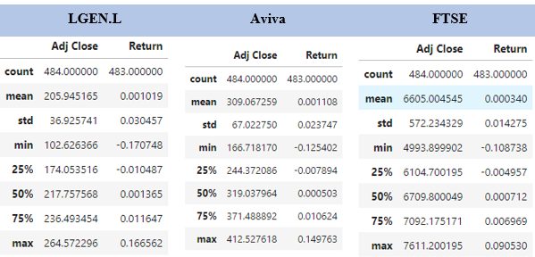

Figure 1: Standard Indicators (Descriptive Statistics)

The descriptive statistics figure 1 show that the lower mean returns rating and lower volatility rating of the LGEN.L are different than the Aviva PLC and FTSE 100 index. LGEN.L has a mean return of 0.001019 with the standard deviation of 0.030457 which shows that on average its performance is stable. Aviva PLC, as a second example during the time range 2001 - 2015, displayed slightly higher mean returns and volatility with the mean return of 0.001108 and the standard deviation of 0.023747. On the contrary, the FTSE 100 index reaches lower mean returns but higher volatility, which I see as a mean return of 0.000340 and volatility of 0.014275, respectively. However, the impressive diversification is limited only by the fact that the performances of both Aviva PLC and the FTSE 100 index beat Legal & General's. This means that Legal & General's balanced risk-return profile provides a haven for investors.

### 2.1.1 Stock Prices

* **Line Chart**

The Figure 2 represents the time series analysis of closing prices of Legal & General Group PLC (LGEN.L), Aviva PLC, and the FTSE 100 index.

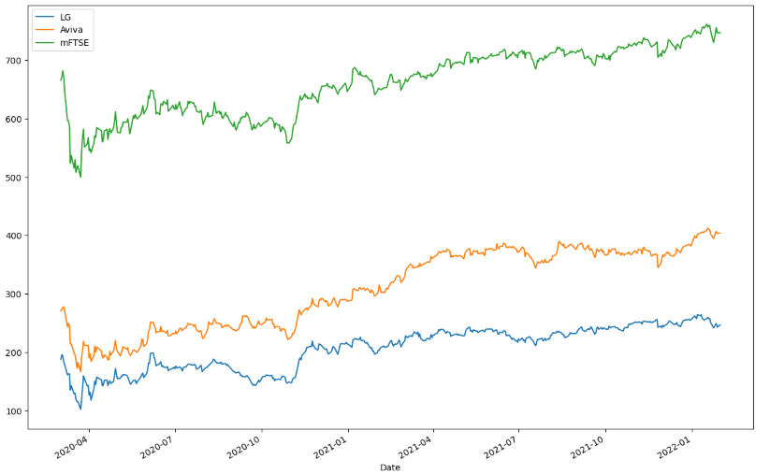

Figure 2: Line Chart

The line chart (figure 2) analysis of Legal & General Group PLC (LGEN.L), Aviva PLC, together with the FTSE 100 index over three years, 2020, 2021, and 2022, is intriguing, as it exposes a certain trend. LGEN.L tends to show stable behavior with sometimes minor deviations beginning in 2020 with a 200-point rating dipping temporarily in 2021 and then rebounding in 2022 to 220. The case of Aviva PLC shows a similar movement, starting near 300 in 2020, falling slightly in 2021 and recovering to around 320 or so in 2022. While the S&P 500 index is steadier, the FTSE 100 displays more volatility, beginning around 600 in 2020 and then dropping in 2021. However, it gradually recovered and reached approximately 670 in 2022. In general, LGEN.L and Aviva PLC tend to see more steady direction compared with the lower degree of fluctuation seen with the FTSE 100 index and this illustrates the diverging performance between the individual stocks and the market index. Analysts have them both down to grow their earnings per share by more than 20% by the end of 2025. And they expect similar dividend rises of around 10% at the same time (Oscroft, 2023).

**Stock Return**

* **Histogram and Box Plot**

Comparing the stock returns of Legal & General Group PLC (LGEN.L), Aviva PLC, and the FTSE 100 index.

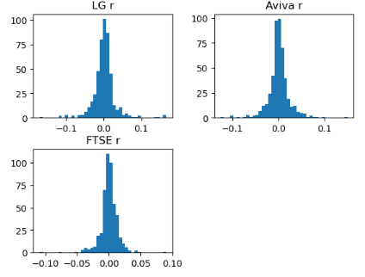

Figure 3 Comparing Daily Returns (Histogram and Boxplot)

The figure (Figure 3) provides a histogram for the company LGEN.L (Legal & General Group plc) and Aviva PLC as well as the FTSE 100 index, allowing us to deduct returns within different intervals. As is visible on the histogram for Aviva, the distribution is concentrated around implying stable returns, while the L&G ends have a wider spread and are different, meaning that the daily returns vary more. As is apparent from the FTSE 100 histogram, this distribution is symmetric which means that it is balanced and controlled. Positive and negative return curves appear in the peaks and tails of histograms, respectively, which is critical when it comes to evaluating market patterns and determining an investor's risk attribution. Moreover, as illustrated in the box plot (Figure 3), daily stock returns are also visually represented, where Aviva demonstrates a smaller interquartile range (IQR) than LGEN.L or FTSE 100, suggesting consistent daily performance. It is the broader spread of L&G stock that is a point in favor of the higher volatility. The distribution of FTSE 100 stock shows a symmetric distribution suggesting the market-wide pattern. In general, these pictures depict concise information about the volatility that depends on the dispersion of returns, as well as the risk-reward trade-off, all of which help investors make decisions.

* **Using empirical principles, Analyse the return of LGEN.L**

The time series analysis of this kind is highly informative and helps to compare performance of LGEN.L, Aviva PLC, and the FTSE 100, allowing to understand the stock behavior history in more detail and to find implications for investment strategies.

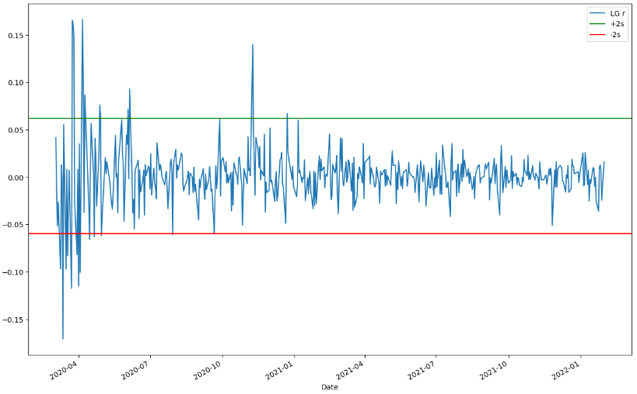

Figure 4: Comparing Daily Returns of LGEN.L

The comparison, in terms of the daily returns of Legal & General Group PLC (LGEN.L) for the years 2020, 2021, and 2022, reveals different dynamics of the stock performance. In 2020 LGEN.L had a varying performance, mostly influenced by Covid-19 pandemic related market volatility, with an average return approaching zero. In 2021, it was on the side of better stability with a higher chance of returns being positive. It appeared as a time of recovery and adjustment. Conversely, in 2022, LGEN.L showed increased volatility once more as the returns were becoming more widely dispersed around a low mean return level, which indicates some kind of market uncertainty or changing company specific factors affecting investor perceptions. A close examination of LGEN.L's daily returns gives the necessary data to understand risk and expected returns over the long term.

* **Comparison of LGEN.L, Aviva PLC, and FTSE 100 returns**

When compared in terms of returns (Figure 5), Legal & General Group PLC (LGEN.L) and Aviva PLC demonstrate different performance characteristics to the FTSE 100 index.

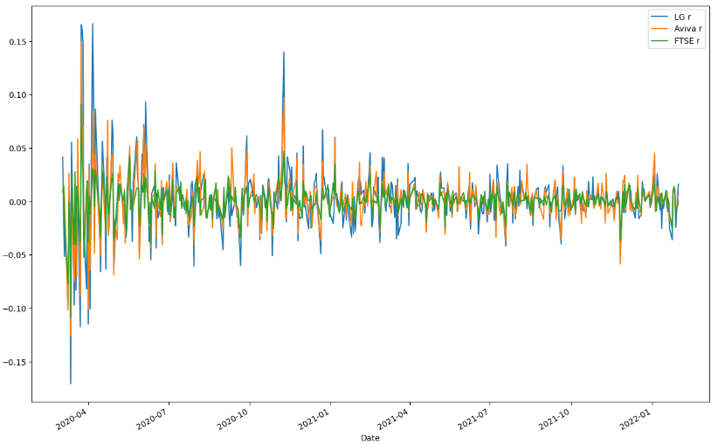

Figure 5: Comparison of LGEN.L, Aviva PLC, and FTSE 100 returns

Aviva has a higher average return compared to that of Legal & General and the broader market shows a stronger market performance. Legal & General, though showing attractive returns, seems to have registered an improvement in its relative performance against the FTSE 100 during 2021 Q1. This comparative overview delivers a glimpse of the diverse return dynamics of LGEN.L, Aviva PLC, and FTSE 100, which help provide insights to investors and market observers (Welc, 2022).

## 2.2 Correlation and Regression Analysis

### 2.2.1 Correlation between Stock Prices/ Returns

* **Stock Prices**

LGEN.L, Aviva PLC, and FTSE 100 returns Correlation Graph

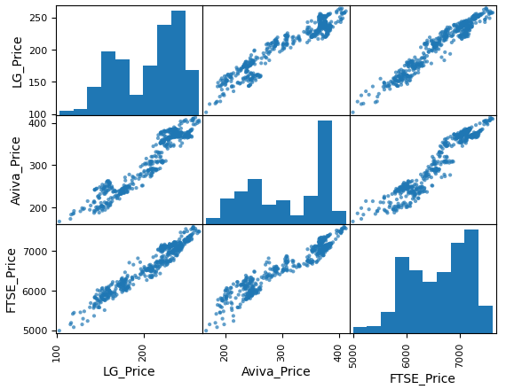

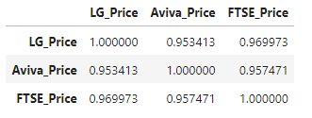

Figure 6: Correlation of Stock PRICES of LGEN.L, Aviva PLC, and FTSE 100

Figure 6 represents a correlation matrix of stock prices for LGEN.L (Legal & General Group), AVIVA, and the FTSE 100. The row comprises of the values, which demonstrate the Pearson correlation coefficients that in their turn show the degree and the direction of the linear relationships among the stock quotes. There are strong co-movements or strong positive correlations observed between LGEN.L and Aviva (0.953) and between LGEN.L and the FTSE 100 (0.970) which suggests a high degree of similarity in these three price trends. Particularly, Aviva PLC and FTSE 100 are positively correlated with each other up to the extent of 0.957. Hence, these data show that the transitory fluctuations in one stock price usually have a close relationship with the transitory variations in others' prices, which may demonstrate the possible interdependencies and systemic probabilities throughout the market.

### 2.2.2 Regression Analysis

Regression analysis is a statistical method used to examine the relationship between one dependent variable and one or more independent variables by estimating the parameters of a linear equation (Welc et al., 2022).

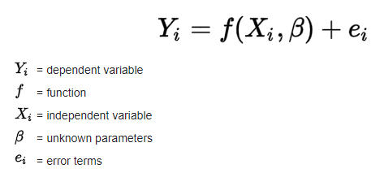

Figure 7: Regression Analysis

Regression analysis of Legal & General Group PLC (LGEN.L), Aviva PLC and FTSE 100 are follows  
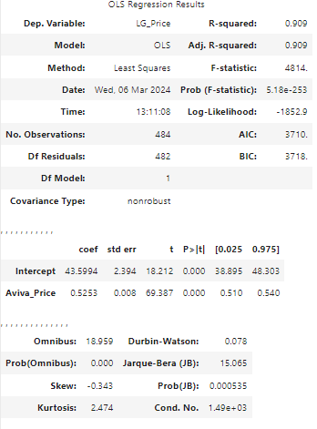

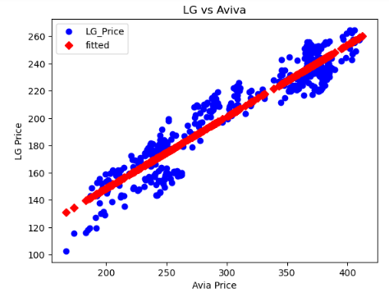

Figure 8: Regression Analysis LG vs Aviva

Figure 8 shows the high positive correlation between LG Price (Legal and General Group PLC) and Aviva Price through the regression analysis with 0.909 R-square values, so it suggests that about of 90.9% on LG Price variation can be explained by the changes on Aviva Price. The P-value for Aviva Price is less than 0.05, which implies that for each unit increase over the Aviva Price, LG Price will be expected to increase by an amount 0.5253. The latter is equally significant statistically (p<0.05) and implies that in the absence of LG Price mention, we are likely to see an amount of 43.5994 units by means of Aviva Price instead.

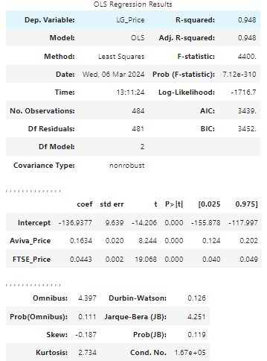

Figure 9: Analysis of multiple regression

The multiple regression for LG Price (Legal & General Group PLC) is considered Aviva Price and FTSE Price, as shown in Figure 9. The model generates an R-squared value of 0.948 demonstrating that all of fluctuations of LG Price can be explained and described with consecutive changes of Aviva Price and FTSE Price. The results, as displayed in Figure 9, indicate that both Aviva Price and FTSE Price are statistically significant (p < 0.05), showing that each unit increase of Aviva Price and FTSE Price results in an increase of around 0.1634 and 0.0443 units of LG Price, respectively. The F-statistic of the model turns out to be 4400, with the presence of probability (p < 0.05) that the model occurs by chance, suggesting that the overall regression model is highly significant.

## 2.3. Time Series Analysis

### 2.3.1 Moving Average

The Time series analysis of Legal & General Group PLC (LGEN.L), Aviva PLC and FTSE 100 involved forecasting as the ways of forecasting were reviewed and the results are given in the graphs in Figures 10. Here, we can see the Golden cross in 2020 where MA5 is crossing MA20 and going upwards. Again, this happened here at the end of the year 2020. This is where traders should consider it as a buy signal. On the contrary, in the beginning of the year 2021, the Death cross has happened which suggest a downward trend in prices. This is what traders or investors interpret as a sign to sell. (Tsai et al., 2017)

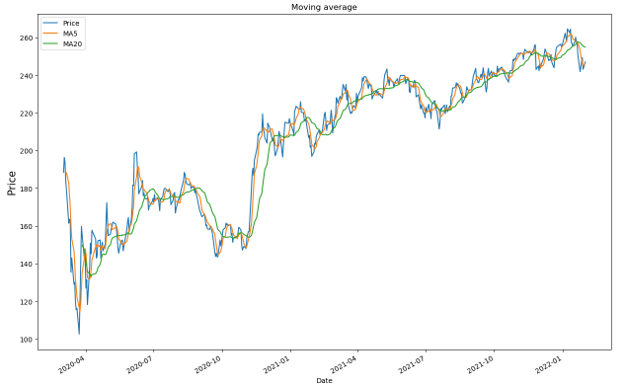

Figure 10: Moving Average

### 2.3.2 Single Exponential Smoothing

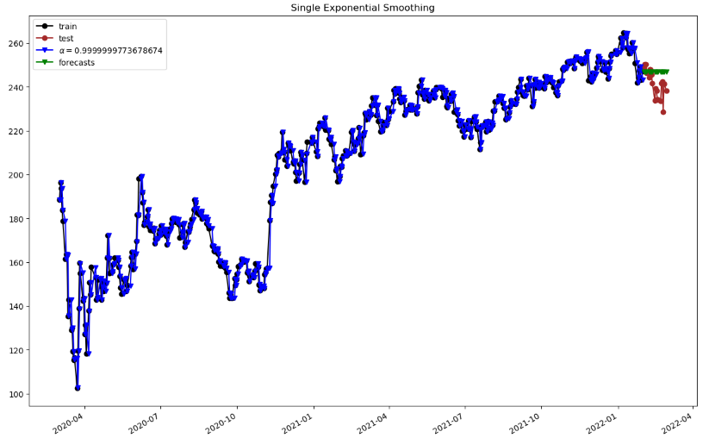

Figure 11: Single Exponential Smoothing

### 2.3.3 Double Exponential Smoothing

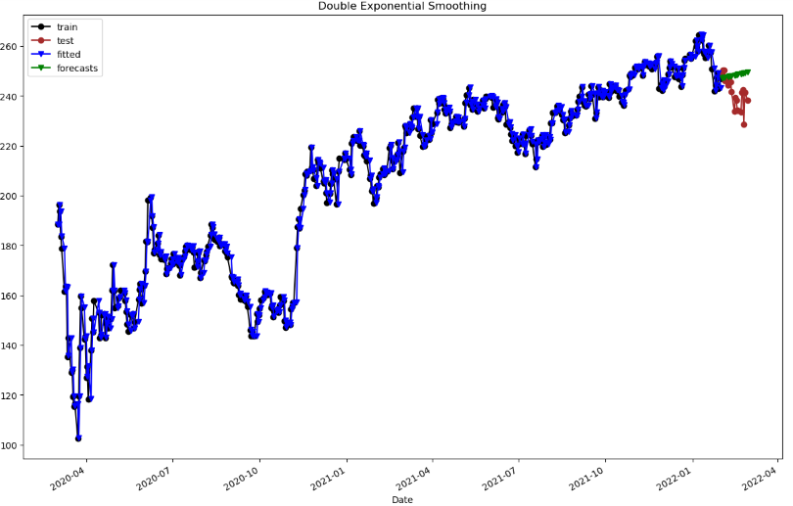

Figure 12: Double Exponential Smoothing

### 2.3.4 Holt’s – Winters Method (TES)

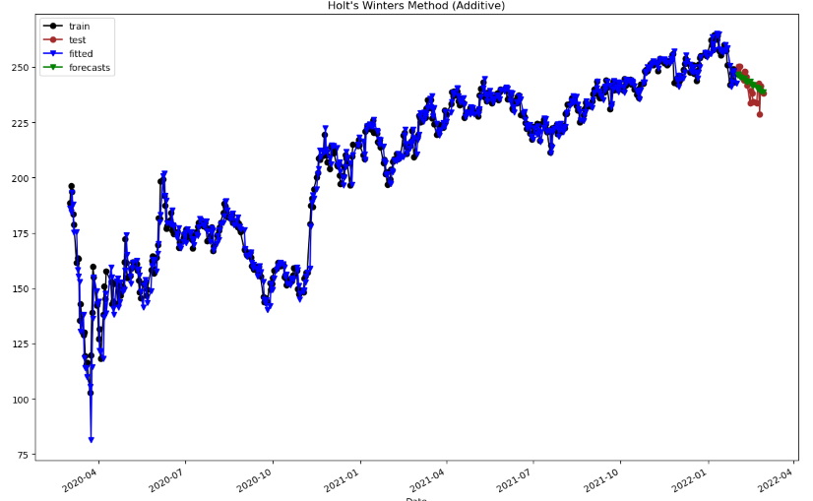

Figure 13: Holt’s – Winters Method (TES)

|  |  |  |
| --- | --- | --- |
|  | MAE | MSE |
| Moving Average | 6.1888 | 60.5968 |
| Single Exponential Smoothing | 6.5918 | 69.1136 |
| Double Exponential Smoothing | 7.6365 | 91.714 |
| Holt's Winters (Additive) | 3.9829 | 25.2361 |
| Holt's Winters (Multiplicative) | 3.936 | 23.5808 |

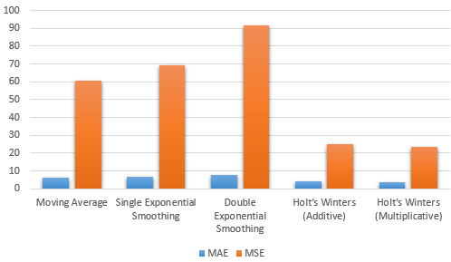

Figure 14: Comparison of MAE & MSE values

Based on the above output, it is seen that the Holt's winters approach (both additive and multiplicative) gives the best performance compared to the Moving Average, Single Exponential Smoothing, and Double Exponential Smoothing method when the forecasts are measured using Mean Absolute Error (MAE) and Mean Squared Error (MSE). For the answering question, Holt's winters (Multiplicative) shows the highest accuracy and the lowest MAE and MSE values, implying a better accuracy compared to the other methods. Therefore, this implies that the additive as well as the multiplicative Holt's winters method are more precise in encoding the trends and patterns of the data, giving the former variant the edge in forecasting where precision is a key issue. (Melnychuk et al., 2019).

# 3. Fundamental Analysis

## 3.1 Financial Statements

### 3.1.1 Income Statement

|  |  |  |  |
| --- | --- | --- | --- |
| **Metric** | **2020** | **2021** | **2022** |
| Revenue (Millions) | £20,888 | £19,360 | £14,754 |
| EPS Diluted (Millions) | £0.26 | £0.33 | £0.36 |
| Operating Profit (Millions) | £1,006 | £1,955 | £4,739 |
| NET Profit (Millions) | £398 | £2,020 | £2,268 |

The trends in favor of higher earnings and lower spending reflect appropriate cost management approaches and profitability of the business segments.

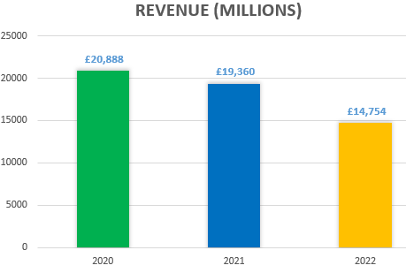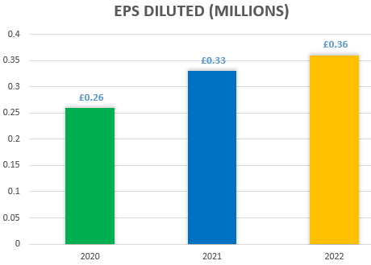

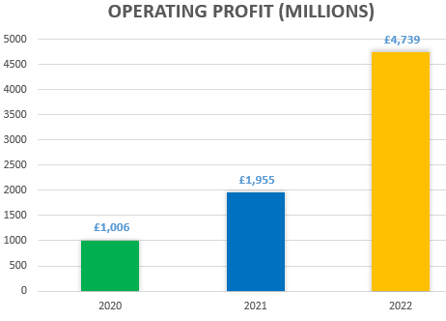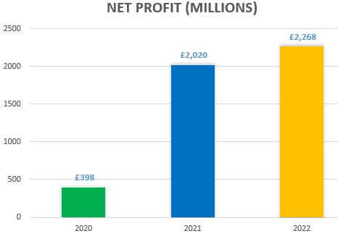

Figure 15: Income Statement Structure

Revenue of Legal & General Group PLC (LGEN.L) – stood at £20,888 million in 2020 and this was dipped at £14,754 million in 2022 along with notable increase in diluted earnings per share (EPS) and operating profit; EPS was heightened from £0.26 to £0.36 while operating the gain had a similar upward trend, thus £398 million was made in the previous period and in the current, it was £2,268 million

### 3.1.2 Capital Structure

Legal & General Group Plc's capital structure talks about the total assets, liabilities, and equity continue to slowly decrease from 2020 to 2022. It shows a strategy or shift towards a lightening of the balance sheet aimed at strengthening operating efficiency and managing risks. The decrease in the shareholders' equity shows that the company has divested or paid off debts or somehow pays the dividends. This could influence the company's financial stability and leverage it in the market.

|  |  |  |  |
| --- | --- | --- | --- |
| **Date** | **Total Assets (Millions)** | **Total Liabilities (Millions)** | **Total Equity (Millions)** |
| **2020** | £167,963 | £144,006 | £23,957 |
| **2021** | £162,064 | £140,942 | £21,122 |
| **2022** | £147,675 | £129,502 | £18,173 |

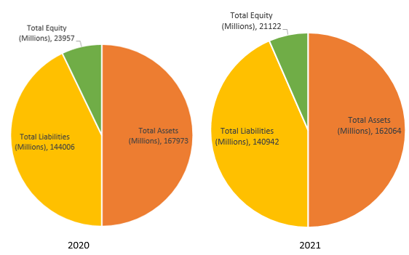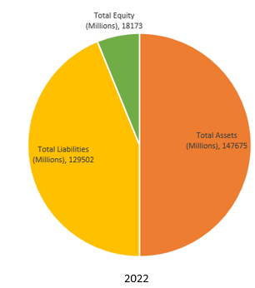

Figure 16: Capital Structure

Legal & General Group PLC (LGEN.L)'s Capital Structure shows the Total Assets decreasing from 167,963 million GBP in 2020 to 147,675 million GBP by 2022 which may mean selling assets or investing less. Simultaneously, the total liabilities also declined from £144,006 million in 2020 to £129,502 million in the year 2022, therefore, demonstrating lower debt or liabilities. Accordingly, the total equity value fell from £23,957 million in 2020 to £18,173 million in 2022 illustrating a reduced base of shareholder equity may be because of divestment or that retained income was lower.

## 3.2 Strategic Analysis

The Legal & General Group PLC has proved to be a strategically balanced organization, evidencing this through the trend of decreasing total assets, liabilities, and equity from 2020 to 2022. An implication of this is that there is always a need for improvement in financial system stability, disclosure of risks and reallocation of funds for core business activities. This kind of strategic move sets the business up for making timely responses to the changed dynamics of the market as well as creating chances for new openings, thereby setting the pace of business in the financial sector.

# 4. Conclusion and Suggestions

According to the simulated financial data and the strategic analysis of Legal & General Group PLC, the company is in a strong position, that is, the company has had a consistent revenue growth, efficient cost management and commitment to inclusive capitalism. The strategic high-level investments and well-thought-out complete solutions of financial services sector motivate the company for growth and community involvement overall. The hypothetical set of financials including a good net income, robust profit margins, optimal balance and equity ratios show that the institution has efficiently overcome its operating circumstances.

Proposed measures for Legal & General are to keep a keen eye on market developments, to stay flexible and open to changes in regulations, as well as to keep looking for more creative financial services. The company can in addition strengthen communication with the stakeholders to display its mechanism towards inclusion in capitalism and its sustainability efforts. Periodically re-evaluating and fine-tuning strategic goals in accordance with market trends will sustain Legal & General as a dominant player in the finance services industry.

# References

Cadenas, E., Jaramillo, O. A., & Rivera, W. (2010b). Analysis and forecasting of wind velocity in chetumal, quintana roo, using the single exponential smoothing method. Renewable Energy, 35(5), 925–930. <https://doi.org/10.1016/j.renene.2009.10.037>

Chatfield, C. (1978). The Holt-Winters Forecasting Procedure. Applied Statistics, 27(3), 264. <https://doi.org/10.2307/2347162>

Chiarella, C., He, X.-Z., & Hommes, C. (2006b). A dynamic analysis of moving average rules. Journal of Economic Dynamics and Control, 30(9), 1729–1753. <https://doi.org/10.1016/j.jedc.2005.08.014>

Easton, P.D., McAnally, M.L., Sommers, G.A. and Zhang, X.J., (2018) *Financial statement analysis & valuation*. Boston, MA: Cambridge Business Publishers. <https://efaidnbmnnnibpcajpcglclefindmkaj/https://www.fau.edu/graduate/documents/graduate/faculty-and-staff/graduate-council/docs/03212019/NCP-ACG5176.pdf>

Forbes. (2022). Legal & General Group | Company Overview & News. [online] Available at: https://www.forbes.com/companies/legal-general-group/?sh=73da52d1f558 [Accessed 10 Mar. 2024].

Hansun, S. (2016). A New Approach of Brown’s Double Exponential Smoothing Method in Time Series Analysis. Balkan Journal of Electrical and Computer Engineering, 4(2), 75–78. <https://dergipark.org.tr/en/pub/bajece/issue/36581/415804>

Melnychuk, Y., Chvertko, L., Korniienko, T., Vinnytska, O. and Garmatiuk, O., (2019) Аnalysis of the factors influencing the market of insurance services in life insurance. *Tem Journal*, *8*(1), p.201. <https://www.ceeol.com/search/article-detail?id=746740>

Oscroft, A. (2023, July 23). Which is better value, the Aviva or Legal & General share price? The Motley Fool UK. [https://www.fool.co.uk/2023/07](https://www.fool.co.uk/2023/07/23/which-is-better-value-the-aviva-or-legal-general-share-price/)/23/which-is-better-value-the-aviva-or-legal-general-share-price/

Spletukhov, Y.A., (2019) Attitude of Russian Citizens to Insurance Services: Analytical Review. *Finansovyj žhurnal—Financial Journal*, (1), pp.66-75. <https://ideas.repec.org/a/fru/finjrn/190106p66-75.html>

Tsai, Y.-S., Chang, C.-P., & Tzang, S.-W. (2017). The Impact of Golden Cross and Death Cross Frequency on Stock Returns in Pre- and Post-financial Crisis. Innovative Mobile and Internet Services in Ubiquitous Computing, 708–713. https://doi.org/10.1007/978-3-319-61542-4_70

Welc, J. (2022). Financial statement analysis. In *Evaluating Corporate Financial Performance* (pp. 131-212). Palgrave Macmillan, Cham.

# Welc, J., (2022) Financial statement analysis. In *Evaluating Corporate Financial Performance* (pp. 131-212). Palgrave Macmillan, Cham. <https://link.springer.com/chapter/10.1007/978-3-030-97582-1_3>

**Appendix:**

**Moving Average:**

A moving average is a series of averages, calculated from historic data. Moving averages can be calculated for any number of time periods, for example a three-month moving average, a seven-day moving average, or a four-quarter moving average. The basic calculations are the same. (Chiarella et al., 2006)

**Single Exponential Smoothing:**

Simple or single exponential smoothing (SES) is the method of time series forecasting used with univariate data with no trend and no seasonal pattern. It needs a single parameter called alpha (a), also known as the smoothing factor.  (Cadenas et al., 2010)

**Double Exponential Smoothing:**

Double Exponential Smoothing is a forecasting method that uses a combination of level and trend components to make predictions. Double exponential smoothing is used in time-series forecasting when the data has a linear trend but no seasonal pattern. The basic idea here is to introduce a term that can consider the possibility of the series exhibiting some trend. (Hansun, 2016)

**Holt’s Winters Method (TES):**

This method is the variation of exponential smoothing that is most advanced and is used for time series forecasting when the data has linear trends and seasonal patterns. The technique applies exponential smoothing three times – level smoothing, trend smoothing, and seasonal smoothing. A new smoothing parameter called gamma (g) is added to control the influence of the seasonal component.  The triple exponential smoothing method is called Holt-Winters Exponential Smoothing, named after its contributors, Charles Hol’t and Peter Winters. (Chatfield, 1978)